**DAILY ONLINE ACTIVITIES SUMMARY**

|  |  |  |  |
| --- | --- | --- | --- |
| **Date:** | 25/06/2020 | **Name:** | Krishnitha |
| **Sem & Sec** | 4th sem, A Section | **USN:** | 4AL18CS039 |
| **Online Test Summary** | | | |
| **Subject** | NA | | |
| **Max. Marks** | NA | **Score** | NA |
| **Certification Course Summary** | | | |
| **Course** | Web Development Engineer | | |
| **Certificate Provider** | AWS Educate | **Duration:** | 3:30 hrs |
| **Coding Challenges** | | | |
| **Problem Statement:**  Write a C Program to reverse the rows in a 2d Array. | | | |
| **Status:** Executed | | | |
| **Uploaded the report in GitHub** | | YES | |
| **If yes Repository name** | | <https://github.com/krishnitha/C-coding> | |
| **Uploaded the report in slack** | | YES | |

**Certification Course Details:**

Today I have continued the course “Web Development Engineer” by AWS Educate. In this course today I learnt about ‘Networking-Introduction, Architecture, Troubleshooting, provisioning and Directory service. Today I have completed two modules of this course, And I have also completed the final assessment and project of this course.

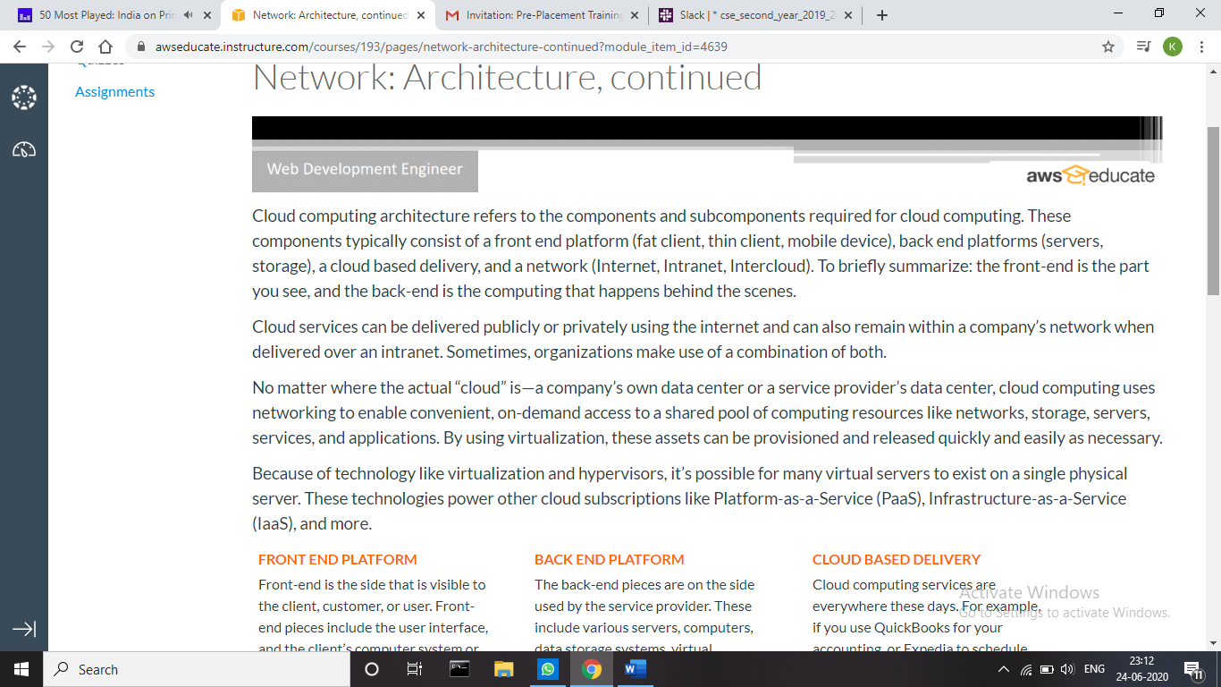

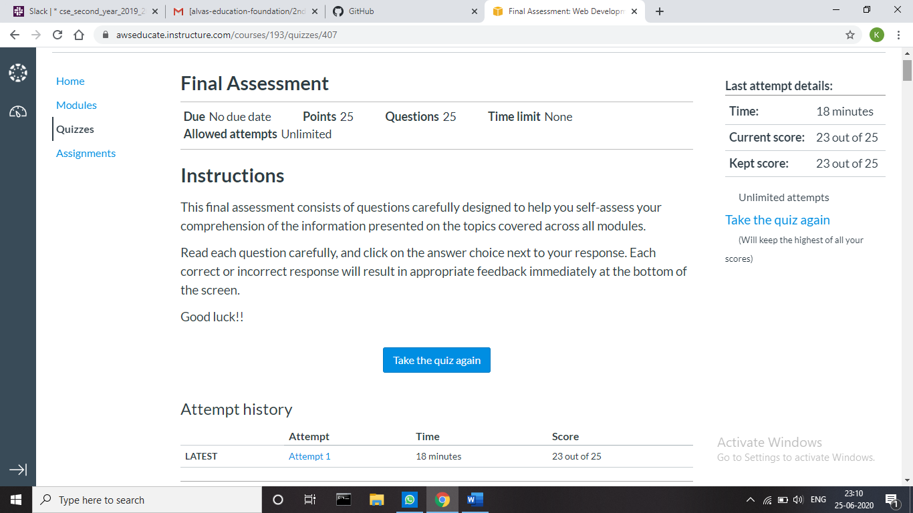

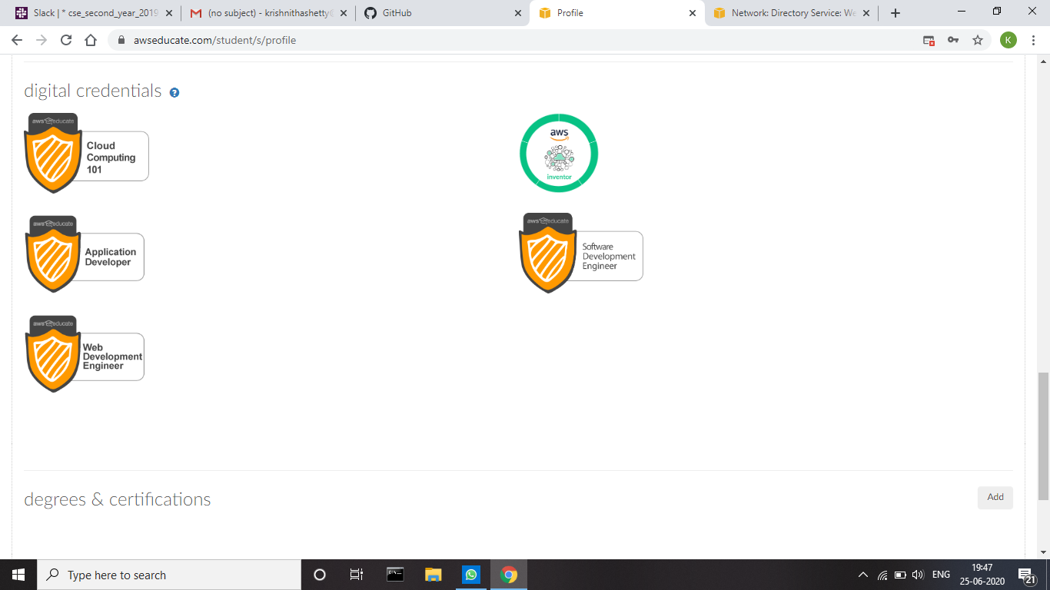

**Webinar Details:**

Today I have attended the webinar on “Why C++, Introduction to OOP and its Features” by Assistant professor Ms. Shruthi Shetty J, CSE department- AIET. The session was very interesting. There was assessment conducted based on the webinar. The test was of MCQ type, there were 6 number of questions of 5 mark each out of which I scored 30.

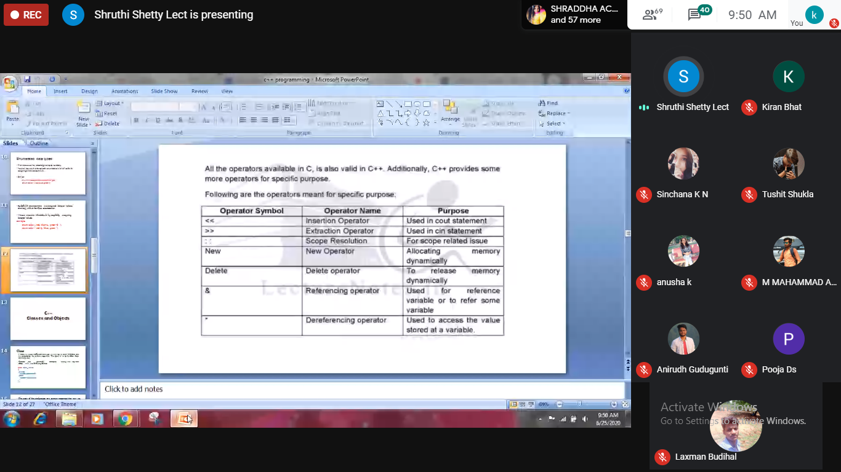

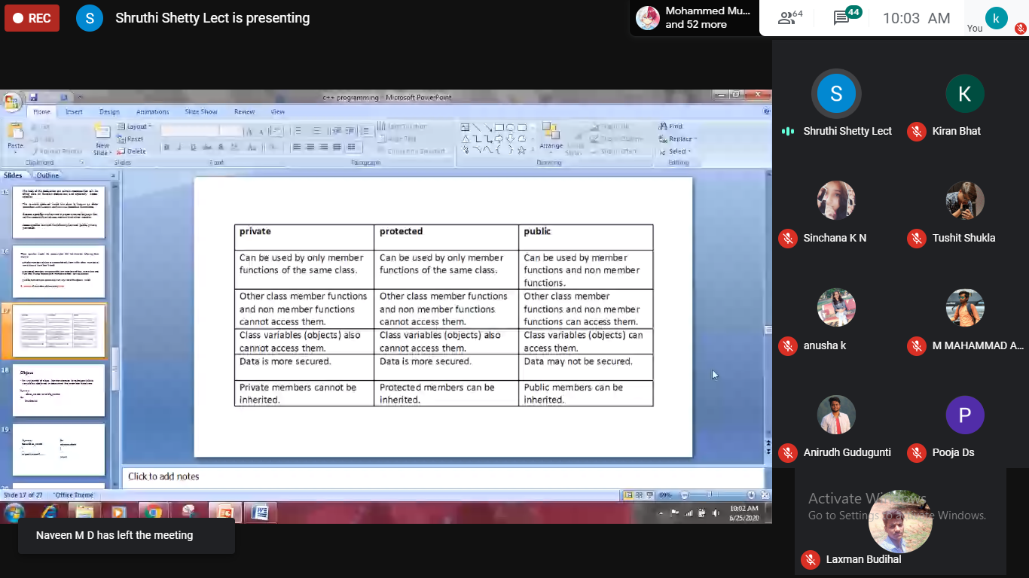

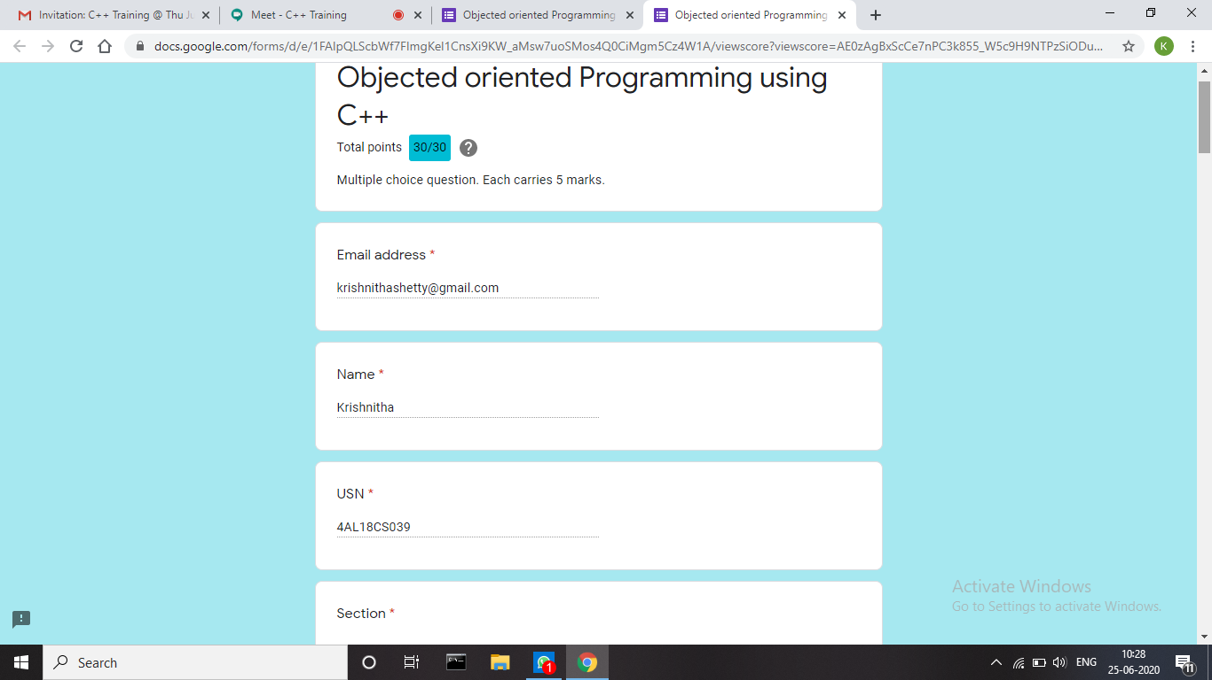

**Coding Challenges Details:**

**Problem 1:** Write a C Program to reverse the rows in a 2d Array.

Given a 2D array arr[][] of size M x N integers where M is the number of rows and N is the number of columns. The task is to reverse every row of the given 2D array.

**Example:**

Input: arr[][] =  
{ {1, 2, 3},  
{4, 5, 6},  
{7, 8, 9} }

Output:  
3 2 1  
6 5 4  
9 8 7

Input**:** arr[][] =  
{ {1, 2},  
{4, 5},  
{7, 8},  
{9, 10} }

Output:  
2 1  
5 4  
8 7  
10 9

**Solution:** Uploaded it in GitHub

